**Overview of the Generator Process**

The generator in **StyleGAN** creates high-resolution images by gradually transforming latent vectors into complex image structures. The key techniques include:

1. **Latent Vector (z → w)**: Encodes meaningful variations in the generated image.
2. **Style Modulation**: Controls different aspects of the image, like color or texture, using separate styles.
3. **Noise Injection**: Adds fine-grained randomness to produce varied images.
4. **Progressive Growth**: Builds images from low to high resolution in stages.

**Step-by-Step Code Explanation**

**1. Imports and Library Setup**

* We use torch (PyTorch) to build and train neural networks.
* torch.nn provides layers and modules, like convolution or normalization.
* torch.nn.functional provides functions like activations, which are useful for direct operations.
* numpy helps with numerical operations (e.g., Gaussian kernel).

**2. Defining Custom Linear Layer – MyLinear**

* Linear (fully connected) layers transform the input latent vector into meaningful representations.
* Learning Rate Multiplier (lr_mul): Scales weight updates, stabilizing training.
* Usage: Converts latent input (512-dimensional) into styles or other feature representations.

**3. Custom Convolution Layer – MyConv2d**

* Convolutional layers capture spatial information (e.g., edges, textures).
* Importance in StyleGAN: Allows the generator to build images layer-by-layer.
* Weight Scaling: Helps control the gradients to improve stability.

**4. Pixel-Wise Normalization – PixelNormLayer**

* Normalizes each pixel to have a unit variance, ensuring stable training.
* This layer ensures that no feature dominates, encouraging the generator to use all features.

**5. Noise Injection Layer – NoiseLayer**

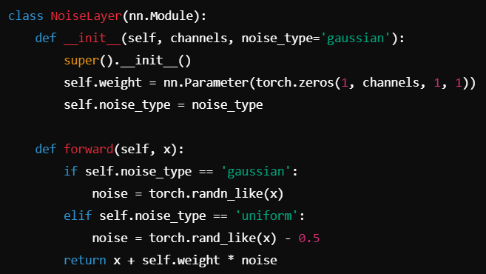

* Adds noise to the feature map, which creates small random details like hair strands or textures.
* Gaussian noise: Works well in most cases since it adds randomness centered around 0.

**6. Style Modulation – StyleMod**

* Modulates the style using the latent vector w.
* Different parts of the image (e.g., color, texture) are controlled by different latent dimensions.

**7. Gaussian Blur Layer – BlurLayer**

* Applies Gaussian blur to smooth the image and reduce artifacts.
* Blurring helps in progressive growing, making transitions smoother when generating images.

**8. Generator Architecture**

* Builds the image progressively from a small constant feature map.
* Uses convolutions, noise injection, pixel normalization, and style modulation to form the final image.

**9. Training the Generator on a Dataset**

To use the generator for generating images, we would need to:

1. Train it on an image dataset (like CelebA, FFHQ) using a **discriminator**.
2. Use an **adversarial loss** (e.g., Wasserstein loss).
3. Gradually grow the generator and discriminator to support larger resolutions.

**Step-by-Step Training Process for StyleGAN**

**1. Dataset Preparation**

**a. Downloading and Preprocessing the Dataset**

* **Example:** We use the FFHQ dataset.
* **Steps:**
  1. Download FFHQ images from the official repository or other sources.
  2. Resize the images to a square resolution (e.g., 1024x1024 pixels) to ensure consistency.
  3. Normalize the pixel values to the range [-1, 1] to stabilize training.

**b. Why Is This Important?**

* **Consistency**: Ensures that all images fed to the network are of the same dimensions and normalized, facilitating better learning and reducing mode collapse.

**2. Defining the Discriminator**

The **discriminator** evaluates the authenticity of the generated images, learning to differentiate between real (from the dataset) and fake (generated) images.

**Why Is This Important?**

* The discriminator must be powerful enough to distinguish real images from generated ones, improving the generator's performance over time.

**3. Defining the Loss Function**

For training, we can use the **Wasserstein loss**, which helps stabilize training.

**Why Is This Important?**

* Wasserstein loss provides a continuous and differentiable loss surface, helping avoid vanishing gradients often seen in traditional GAN training.

**4. Training Loop**

The training loop involves the following steps:

1. **Sample Real Images**: From the dataloader.
2. **Generate Fake Images**: Using the generator.
3. **Update Discriminator**: Calculate losses for both real and fake images and update.
4. **Update Generator**: Based on the discriminator's feedback.

**Explanation of Each Step:**

* **Sampling Real Images**: We fetch real images from the dataset to train the discriminator.
* **Generating Fake Images**: The generator produces images from random latent vectors.
* **Discriminator Loss**: Measures how well the discriminator can differentiate between real and fake images.
  + **Real Images**: Positive labels to encourage the discriminator to classify them correctly.
  + **Fake Images**: Negative labels to discourage it from identifying them as real.
* **Total Loss Calculation**: The discriminator's total loss combines losses from real and fake images.
* **Gradient Backpropagation**: Backpropagates the loss through the discriminator to update its weights.
* **Generator Loss**: The generator aims to fool the discriminator into classifying generated images as real.
  + We use real labels as feedback for the generator, leading to updates that improve its performance.

**5. Evaluating and Visualizing Generated Images**

After training, you can visualize the generator's outputs to assess the quality of the images produced.

**Why Is This Important?**

* Visual inspection of generated images allows you to evaluate whether the generator has learned meaningful features and can produce high-quality images.

**Conclusion**

The entire training process involves:

1. **Preparing the dataset**: Ensuring uniformity and normalization.
2. **Defining a discriminator**: To evaluate image authenticity.
3. **Loss functions**: Critical for guiding the training.
4. **Iterative training loop**: Alternately improving the generator and discriminator.